**DAILY ONLINE ACTIVITIES SUMMARY**

|  |  |  |  |  |  |  |  |
| --- | --- | --- | --- | --- | --- | --- | --- |
| **Date:** | **02 June 2020** | | | | **Name:** | **KHATHEEJA SAFREENA** | |
| **Sem & Sec** | **4th sem, 2nd year** | | | | **USN:** | **4AL18CS037** | |
| **Online Test Summary** | | | | | | | |
| **Subject** | | **---------** | | | | | |
| **Max. Marks** | | **---------------** | | **Score** | | **-----------** | |
| **Certification Course Summary** | | | | | | | |
| **Course** | **PYTHON FOR MACHINE LEARNING.** | | | | | | |
| **Certificate Provider** | | | **Great Learning** | **Duration** | | | **10 hours** |
| **Coding Challenges** | | | | | | | |
| **Problem Statement:3 program** | | | | | | | |
| **Status: Executed** | | | | | | | |
| **Uploaded the report in Github** | | | | **Yes** | | | |
| **If yes Repository name** | | | | **[http://shafreenasharief / lockdown-coding](http://shafreenasharief / lockdown-coding" \o "http://shafreenasharief / lockdown-coding)**  **[http://shafreenasharief / locked-down--certification-course](http://shafreenasharief / locked-down--certification-course" \o "http://shafreenasharief / locked-down--certification-course)**  **[http://shafreenasharief / Daily\_Report](http://shafreenasharief / Daily_Report" \o "http://shafreenasharief / Daily_Report)** | | | |
| **Uploaded the report in slack** | | | | **Yes** | | | |

Online Test Details: (Attach the snapshot and briefly write the report for the same)

Certification Course Details: (Attach the snapshot and briefly write the report for the same)

Coding Challenges Details: (Attach the snapshot and briefly write the report for the same)

**CERTIFICATION COURSE SUMMARY**:

* Today I'm doing a course on MACHINE LEARNING WITH PYTHON. It is a 10 hours course. I completed 5 module. Which explains about Numpy intro,saving and loading Numpy array,Pandas-Series,Indexing elements of a series,Dictionaries, Data frame, Different ways of indexing in a data frame, Conditional indexing in a data frame, Tools.
* I successfully completed certification course on PYTHON FOR MACHINE LEARNINGon great learning.The course is secluded for 10 hour.Today I completed all the module .I attempted quiz ,which gave me a clear veiw about the topics that were thought and discussed.It consists of 30 modules which also include assessments.

**The concept covered in the course are as follows:**

* **Installation of Python**
* **Numpy**
* Basics of Numpy array
* Broadcasting an array
* Matrix indexing
* Selection techniques
* Saving and loading arrays
* **Pandas**
* Series
* Indexing elements of a series
* Dictionaries
* Data frame
* Different ways of indexing in a data frame
* Conditional indexing in a data frame
* Case Study
* **Tools**
* Jupyter Notebook.

**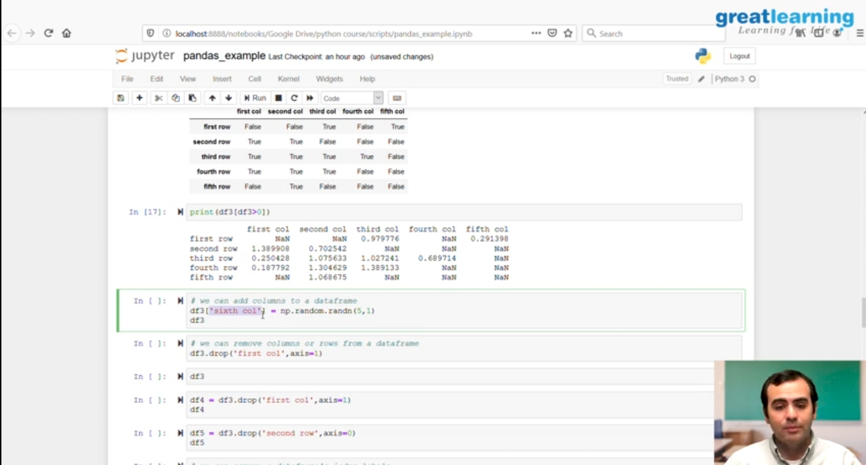**

* **There is the snapshot of the certificate on competition of course.**

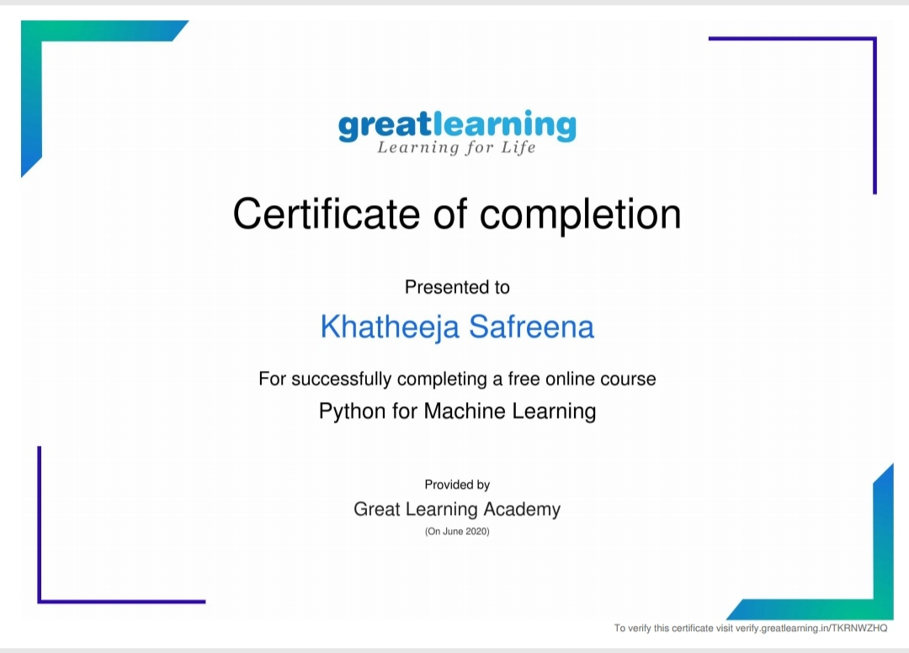

**ONLINE CODING CHALLENGES**:

Today I solved 3 coding challenge,

1. **Given an array of positive integers. Write a C Program to find inversion count of array.**
2. **Write a Java program to find Perfect Sum Problem**
3. **Write a program in java, an array of integer data to be initialized. During the initialization, if a user enters a value other than integer value, then it will throw InputMismatchException exception. On the occurrence of such an exception, your program should print “You entered bad data.” If there is no such exception it will print the total sum of the array.**

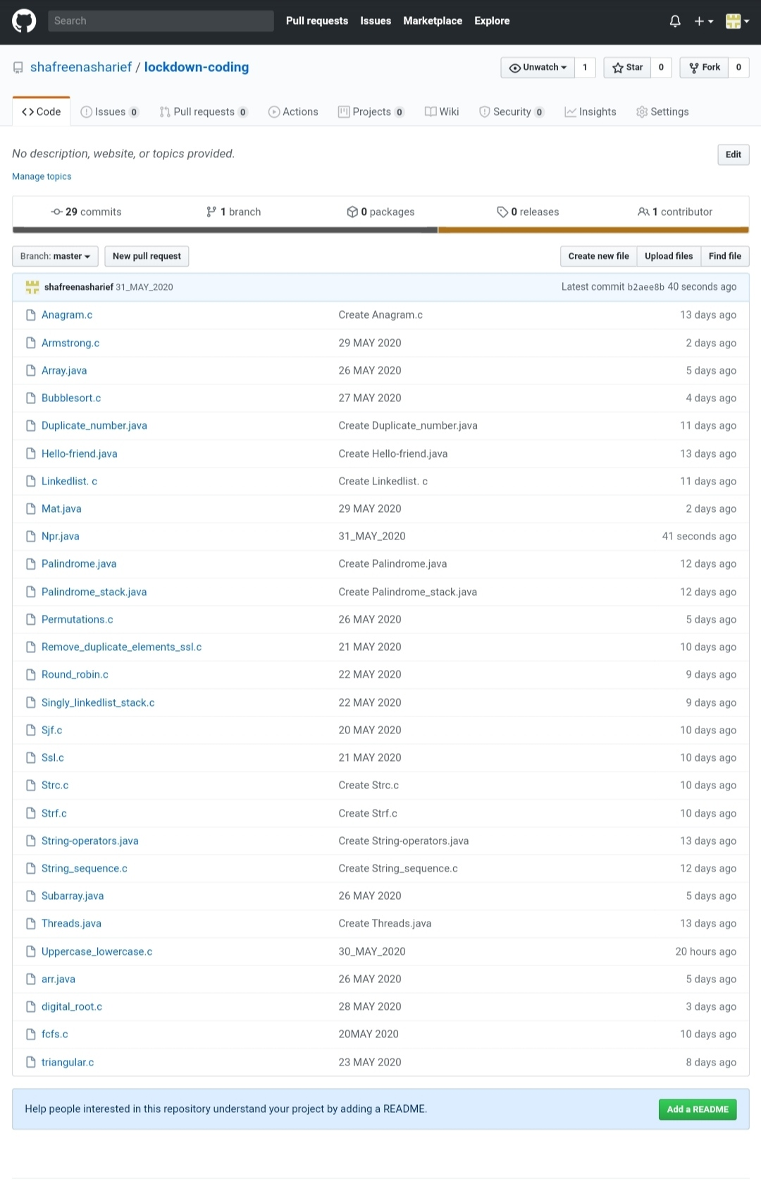**SOLUTION** : I have uploaded the solution of the above 4 coding problems in my GitHub repository.

[http://shafreenasharief / lockdown-coding](http://shafreenasharief / lockdown-coding" \o "http://shafreenasharief / lockdown-coding)

[http://shafreenasharief / locked-down--certification-course](http://shafreenasharief / locked-down--certification-course" \o "http://shafreenasharief / locked-down--certification-course)

[http://shafreenasharief / Daily\_Report](http://shafreenasharief / Daily_Report" \o "http://shafreenasharief / Daily_Report)